

E-Commerce & Digital Marketing
( Course Code: CSC417 )

Name: Muhammad Abdullah
Roll No # FA24-BSE-042
Instructor Name: Mam Faiqa

Lab Assignment# 1

Lab 1 Report
In this lab, I explored practical tools used in real e-commerce workflows to understand market demand, build an online presence, and monitor website performance.
Google Trends:
I used Google Trends to compare product searches in Pakistan and analyze demand patterns. It helped me identify seasonal trends, regional interest, and rising keywords. From an e-commerce perspective, this tool supports product validation, campaign planning, and data-driven marketing decisions instead of relying on assumptions.
Portfolio (Google Sites):
I created a simple portfolio website to present my skills and lab work. In e-commerce and digital marketing, a portfolio acts as a professional online presence that builds trust and credibility. Structuring pages like About, Lab Work, and Contact Info demonstrated how businesses organize content to clearly communicate value to users.
Google Search Console:
I connected my portfolio to Google Search Console to understand website visibility and indexing. I reviewed indexing status, performance data, and mobile usability. For e-commerce, this tool is important for monitoring search performance, detecting technical issues, and improving organic reach through SEO insights.
Conclusion:
Overall, the lab showed how data analysis (Google Trends), digital presence (portfolio), and SEO monitoring (Search Console) work together to support effective e-commerce strategies and improve online business visibility.
1: Trends Comparison
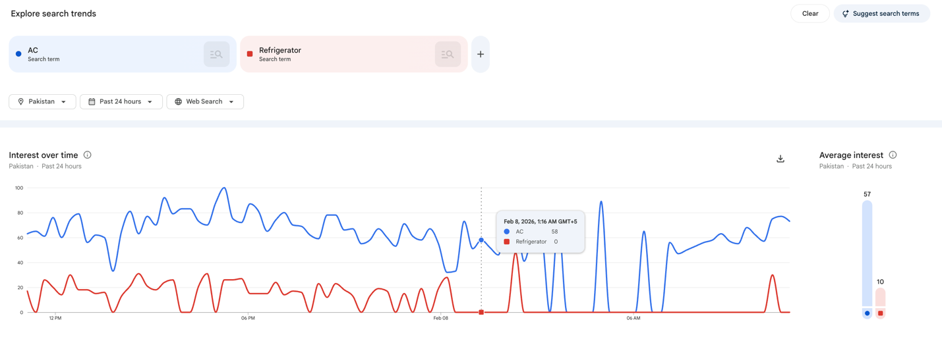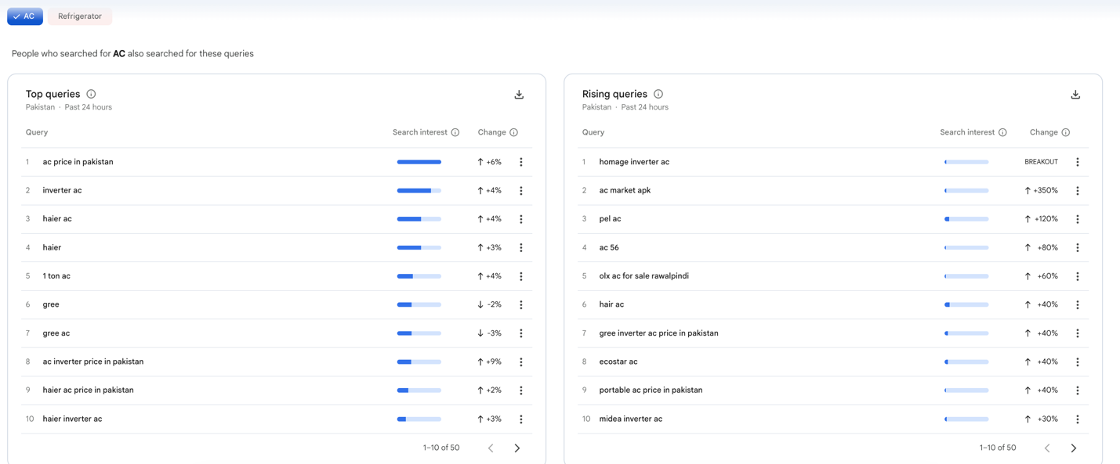
Keyword 1 vs Keyword 2 | Peak Months | Top Region | Rising Query
AC vs Refrigerator | AC: Summer Peaks (May–June typical trend) vs Refrigerator: Steady Year-Round | AC: Karachi & Major Cities vs Refrigerator: Punjab & Mixed Regions | Best inverter AC 2024

Notes Based on Screenshot
- AC average interest ≈ 57
- Refrigerator ≈ 10
- AC has much higher search demand
- Refrigerator shows low but stable interest
2: Competitor Analysis
Platform | Price (PKR) | Reviews | Delivery
Daraz vs Amazon Sneakers | Daraz: ~2,500 – 4,000 | Amazon: ~6,000 – 12,000 | Daraz: Few hundred | Amazon: Thousands+ | Daraz: Local Shipping | Amazon: International Shipping
Extra Insights:
- Daraz focuses on affordability + local sellers
- Amazon emphasizes brand trust + global logistics
- Amazon listings have more structured reviews & trust signals
- Daraz UX optimized for regional buyers & COD model

3: Portfolio
Link: https://sites.google.com/view/abdullahriaz2


